**Unit 5: Functions**

**Lesson 4: Graphing parent functions & Piece wise functions**

Objectives:

* I can graph a parent function.
* I can write a table of values for a parent function.
* I can identify parent functions.
* I can graph a function over a restricted domain.
* I can identify the domain, range and main features of Parent functions.

Agenda:

* Graphing Discussions
* Use your skills

Focus Questions:

1. How do we apply functions in real-life applications?

Online support:

<https://www.youtube.com/watch?v=4WvT_XLFb6U>

Homework: worksheet 5-4.

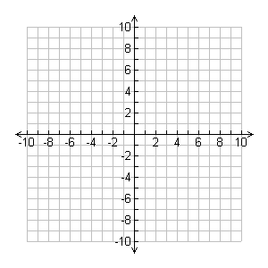**It’s all about graphing: Follow the link first** <https://www.youtube.com/watch?v=YGVnKmq3ap4>

1)Consider the following function $f\left(x\right)=\sqrt{x}$: **Square Root**

1. Fill out the table of values below for the inputs.
2. Graph the function on the grid provided.

|  |  |
| --- | --- |
| x | f(x) |
| 0 |  |
| 1 |  |
| 4 |  |
| 9 |  |

1. Identify the domain, Range.

Click on the link first:

<https://www.youtube.com/watch?v=zbM_I99GquY>

**2)Absolute Value: $g\left(x\right)=\left|x\right|$**

|  |  |
| --- | --- |
| x | g(x) |
| -2 |  |
| -1 |  |
| 0 |  |
| 1 |  |
| 2 |  |
| 3 |  |

Consider the following function

1. Fill out the table of values below for the inputs.
2. Graph the function on the grid provided.
3. Identify the domain, Range.

<https://www.youtube.com/watch?v=XC-JJgdyteY>

3)Consider the following function $g\left(x\right)=x^{2}:quadratic$

1. 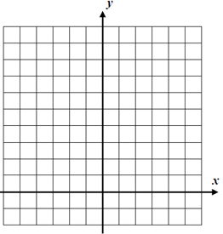Fill out the table of values below for the inputs.
2. Graph the function on the grid provided.
3. Identify the domain, Range.

|  |  |
| --- | --- |
| x | g(x) |
| -3 |  |
| -2 |  |
| -1 |  |
| 0 |  |
| 1 |  |
| 2 |  |
| 3 |  |

****4)**Fu**ncti**on $g\left(x\right)=2^{x}$**  : **Exponential function**

1. Fill out the table of values below for the inputs.
2. Graph the function on the grid provided.

|  |  |
| --- | --- |
| x | g(x) |
| -1 |  |
| 0 |  |
| 1 |  |
| 2 |  |
| 3 |  |

1. Identify the domain, Range.

5) $f\left(x\right)=\sqrt[3]{x}$: **Cube root function** : y = Math= option 4

Graph the following function over the interval

1. Fill out the table of values below for the inputs.
2. Graph the function on the grid provided.
3. The domain is $-8≤x≤8$, the corresponding rang is:

|  |  |
| --- | --- |
| x | f(x) |
| -8 |  |
| -1 |  |
| 0 |  |
| 1 |  |
| 8 |  |



**6) $f\left(x\right)=x^{3}$: cube function**

1. Fill out the table of values below for the inputs.
2. Graph the function on the grid provided.
3. Identify the domain, Range.

|  |  |
| --- | --- |
| x | f(x) |
| -8 |  |
| -1 |  |
| 0 |  |
| 1 |  |
| 8 |  |

Name: ______________ Date: ________________ Homework 5-4

Consider the following function $f\left(x\right)=\sqrt{x }+2$: **Square Root**



1. Fill out the table of values below for the inputs.
2. Graph the function on the grid provided.
3. Identify the domain, Range.

|  |  |
| --- | --- |
| x | f(x) |
| 0 |  |
| 1 |  |
| 4 |  |
| 9 |  |

**2)Absolute Value: $g\left(x\right)=\left|x+2\right|$**

Consider the following function

1. Fill out the table of values below for the inputs.
2. Graph the function on the grid provided.
3. Identify the domain, Range.

|  |  |
| --- | --- |
| x | g(x) |
| -2 |  |
| -1 |  |
| 0 |  |
| 1 |  |
| 2 |  |
| 3 |  |

3)Consider the following function $g\left(x\right)=x^{2}-2:quadratic$

1. Fill out the table of values below for the inputs.
2. Graph the function on the grid provided.
3. Identify the domain, Range.

|  |  |
| --- | --- |
| x | g(x) |
| -1 |  |
| 0 |  |
| 1 |  |
| 2 |  |
| 3 |  |

4) $f\left(x\right)=\sqrt[3]{x}+3$: **Cube root function**

Graph the following function over the interval

1. Fill out the table of values below for the inputs.
2. Graph the function on the grid provided.

Name: __________ Date: ______________

Homework 5-4: Functions.

1. Identify the Domain and Range for the following relations:
2. 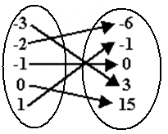b)

Domain ______________________ Domain:______________________

Range ______________________ Range: ______________________

Is this a Function? Is this a Function?

c) Given the graph: d) Given the table:

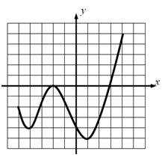

Domain ______________________ Domain ______________________

Range ______________________ Range ______________________

Is this a Function? Is this a Function?

Find the rate of change from x=0 to x=4. Find the rate of change from x=0 to x=4.

Which relation has a greater rate of change c or d?

3.Function Evaluation:

1. $Given: f\left(x\right)=x^{2}+2x-2, find f(2)$ 2. $Given f\left(x\right)=\sqrt{x-2, }$ find f(6)

3. 4.

5. 6.